Install Java IDE & Data Types

Use the following steps to download and install java latest version on Windows
Open the following URL in any browser
https://www.oracle.com/in/java/technologies/downloads/
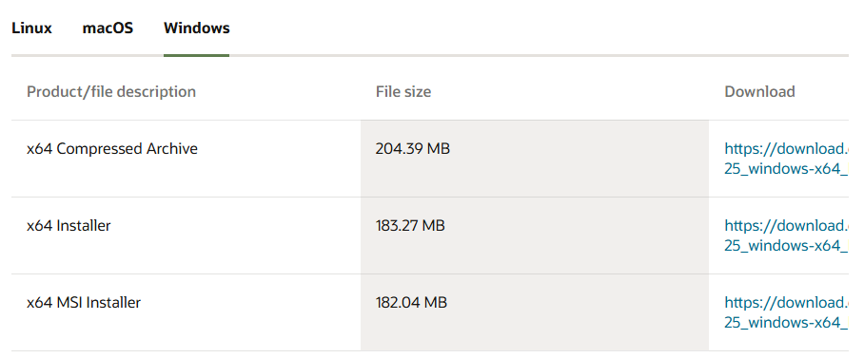

Java.exe and javac.exe commands are present in JAVA_HOME/bin folder
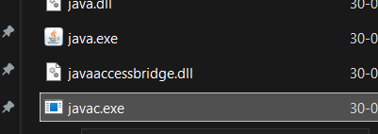
C:\Program Files\Java\jdk-24\bin

Create & Run Java Code using CMD & Notepad.txt
- Open Command Prompt in desired location
- md JavaProgram make directory
- cd JavaProgram change directory
- notepad Welcome.java notepad will get open
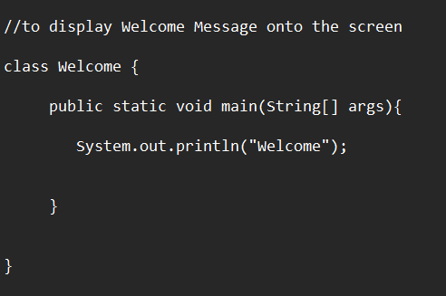
Save the code
- javac Welcome.java
- dir
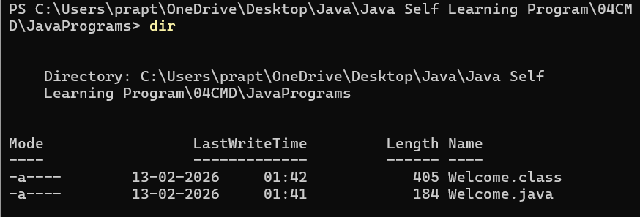
- if error
set path=jdk bin path;%path%;
Compile Java source code file, Welcome.java as follows
- javac Welcome.java
Run Java Byte code, welcome.class as follows
- java Welcome

Note
Every statement in java should end with a semicolon;
Java is case sensitive programming lang means there is a difference between upper case and lower-case letters

System.out.println()
it is used to display messages or the value of variables or both onto the screen

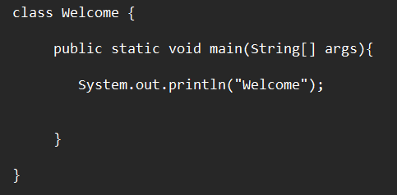
- main() method
- can run directly
- Prints Welcome
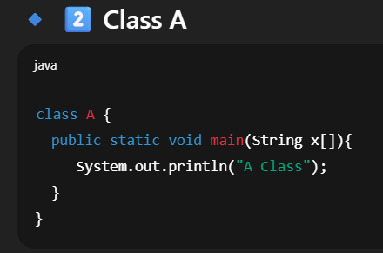
- It has main() method
- Can run directly
- Prints A class
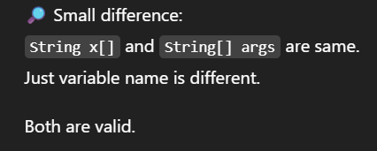
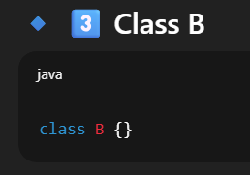
- No main method
- No variables
- No methods


